Augustus Mendy

Southern New Hampshire University

CS-499-10450-M01

Professor Ramsey

September 21, 2025

3-2 Milestone Two Enhancement One Software Design and Engineering.

This paper tells the story of the artifact improvements for software engineering and design. It provides insight into the process of creating the chosen artifact and explains why it was included in this section of our ePortfolio. The story is centered on the knowledge gained via the development of the artifact.

Prompt

The mobile application Inventory App has been chosen as the artifact for the software design and engineering category. Using Android mobile devices, the app's objective is to track an inventory of things. The computer science course CS360 Mobile Architecture and Programming included planning, designing, and developing the software. The relational database SQLite is integrated into the Java programming language used to create the application. The Android Studio IDE is utilized as the development and programming tool. Android Studio's Nexus device emulator is used for the app's testing and operation.

This particular artifact was the result of a comprehensive software engineering and design process. It comprises user interaction with the many screens and functions that the application offers, as well as design considerations for the user experience. Using icons and symbols that are industry-standard will guarantee that the application and its functions are easy to use. Validating input data, designing with security in consideration, and default denying are engineering approaches. Include design and technical considerations for the relationships and usefulness of their algorithms, data structures, and databases in their source code and layouts for various classes and methods. Employ a relational database to hold the information that users produce, read, edit, and remove as a result of using the program.

We demonstrate our proficiency in software design, user needs interpretation, and program relation of activities in an orderly structure through the design and implementation of the mobile application. programming methodology that combines the programmatic portion of an application with the presentation and layout elements of the user interface.

By adding full user CRUD functionality to the item's activity and enhancing the SQLHelper class function and methods' functionality, structure, and efficiency, the major artifact enhancements made the program completely functional. This improvement allows us to manage the trade-offs associated with design decisions while using algorithmic concepts, computer science techniques, and standards relevant to our solution to the creation and evaluation of computing solutions that address a specific problem. By employing user-centered design principles and industry standards in application development, we adhere to best practices and mobile development principles (Figure 1 Design of Add Item Activity Layout). By using user-centered design concepts, we may show that we can apply creative and well-founded computing methods, abilities, and resources to create computer systems that add value and achieve industry-specific objectives. Put quality assurance methods into practice that are successful in locating and removing vulnerabilities.

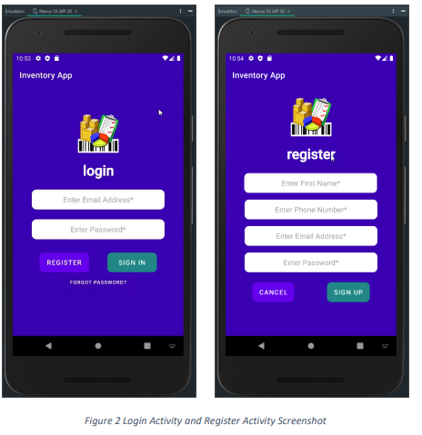

Using the user's name, phone number, and email as part of their credentials allowed us to authenticate them, and our zerotrust policy was demonstrated by a way to retrieve their password in the event that they forgot it. Stress the need of having a security mentality throughout the development process to foresee adversarial exploits in software architecture and designs in order to identify potential weaknesses, address design faults, and guarantee privacy and improved data and resource security. Throughout our whole software development life cycle, we carry out security from the beginning, product assurance, testing, and compatibility checks. For the target development language and platform, use secure coding guidelines.

We use industry-standard JAVA code best practices and approaches, like in-line comments, proper naming conventions, formatting, and indentation, to improve the organization of the application code and make the code easy to understand. camelCase lower case names or lower case dash_names were used to identify methods scope variables, while camelCase CapWords names were used to identify global variables.   
The layout files had lower case names, and the Java class files used camelCase CapWords. To the best of their ability, class methods names reflect the function and behavior of the method.   
Code comments provide a summary of the functionality of classes and methods. The initial lower case word in the camelCase name is used to identify methods that override methods from their superclass. In camelCase, other methods that don't override those from its superclass are named using CapWords.

I first plan and program the goal of my project and my target audience in my capacity as a designer and engineer. Since every audience is different, I should analyze user wants and incorporate them into the idea to build by prioritizing their needs and focusing on the most significant or preferred features first. It's similar to assigning a ranking to the tasks that must be included in the app upon launch. Finding competing apps is crucial, as is examining how they approach the design of the app to fix any UI/UX issues and how those apps displayed and identified aspects that were similar to our proposal. Finding apps that are comparable to the app idea we want to produce by browsing the app store or online is therefore an essential strategy to put into practice.

A lot of information is available about the ideal design process for mobile applications. Comprehending this procedure is essential to creating a high-quality app that our target market will approve. It is doubtful that we can develop a wonderful application on our own since we cannot accomplish things on our own. Seeking assistance to identify our strengths and limitations is crucial throughout the entire app design and development process, from the very beginning to the end. In order to succeed, we must assemble a cooperative team that can assist us in understanding and putting the best practices for mobile app development into practice. To continue looking for ways to develop and enhance the mobile app in order to solve a challenge, concentrate on putting the design elements and the programmatic code into practice.

References:

“Southern New Hampshire University. (2025, September 19). *Milestone Two Guidelines and Rubric Enhancement One: Software Design/Engineering*. Retrieved from Module 3-2 Milestone Two: Enhancement One: Software Design and Engineering: <https://learn.snhu.edu/d2l/common/dialogs/quickLink/quickLink.d2l?ou=1014915&type=coursefile&fileId=Course+Documents%2fCS+499+Milestone+Two+Guidelines+and+Rubric.pdf>.”